C PROGRAMMING
NAME: YOKITHA S
ROLL NO: 241801327
WEEK :7
TOPIC: SEARCHING ALGORITHMS LINEAR AND BINARY
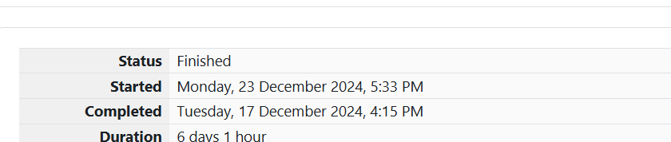
1. Problem Statement:
Sunny and Johnny like to pool their money and go to the ice cream parlor. Johnny never buys the same flavor as Sunny, and they always spend all their money.
Given a list of prices for the flavors of ice cream, find the two flavors that will cost all of their money.
Input Format:
- The first line contains an integer ttt — the number of trips to the ice cream parlor.
- For each trip:
  - First line contains mmm, the total amount of money pooled by Sunny and Johnny.
  - Second line contains nnn, the number of available flavors.
  - Third line contains nnn space-separated integers representing the price of each flavor.
Output Format:
For each trip, print two space-separated integers representing the indices of the two flavors they buy. The indices should be printed in ascending order.
Sample Input:
Copy code
2
4
5
1 4 5 3 2
4
4
2 2 4 3
Sample Output:
Copy code
1 4
1 2

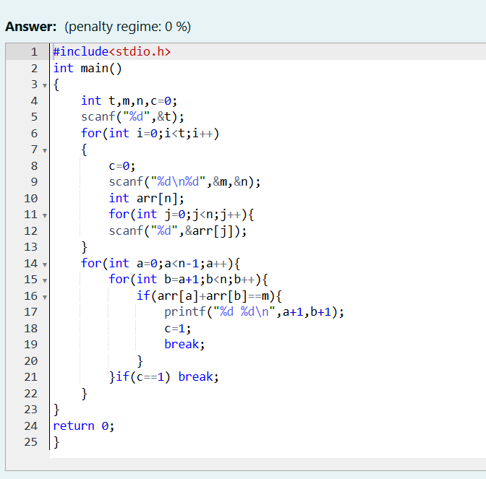
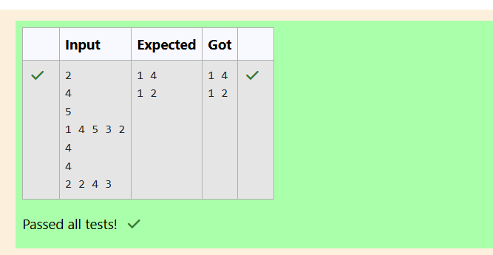
2. Problem Statement:
Numeros the Artist had two lists that were permutations of one another. Unfortunately, while transporting them from one exhibition to another, some numbers were lost from the first list. Can you find the missing numbers?
Input Format:
- First line contains nnn, the size of the first list.
- Second line contains nnn space-separated integers — the first list.
- Third line contains mmm, the size of the second list.
- Fourth line contains mmm space-separated integers — the second list.
Output Format:
Print all the missing numbers in ascending order.
Sample Input:
Copy code
10
203 204 205 206 207 208 203 204 205 206
13
203 204 204 205 206 207 205 208 203 206 205 206 204
Sample Output:
Copy code
204 205 206

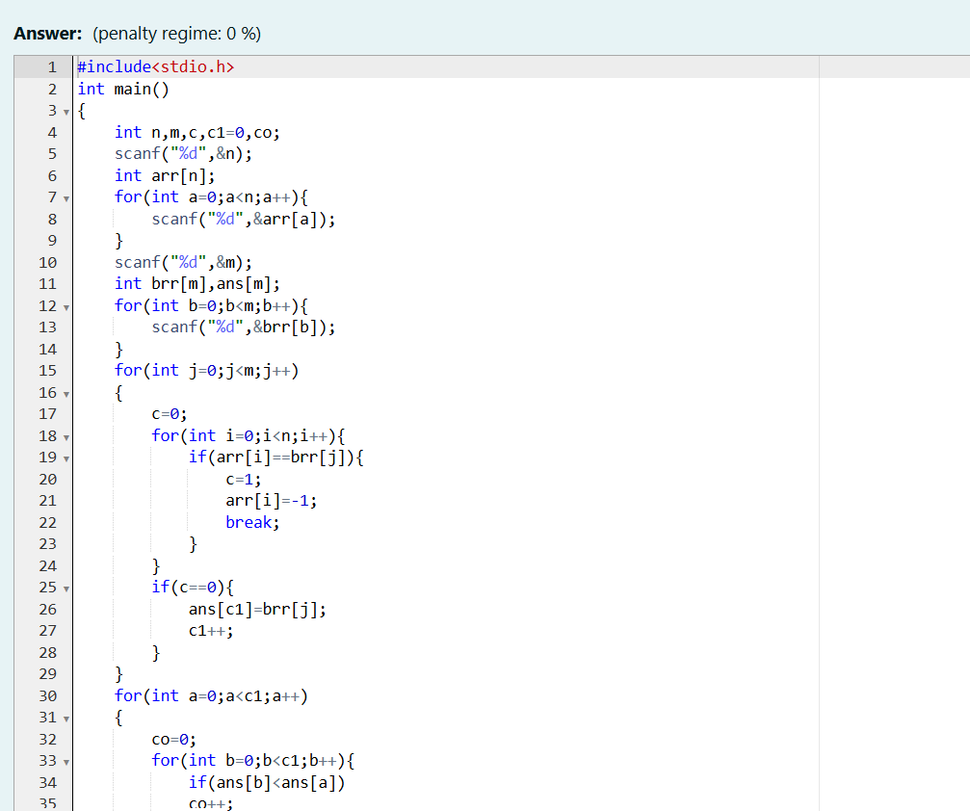
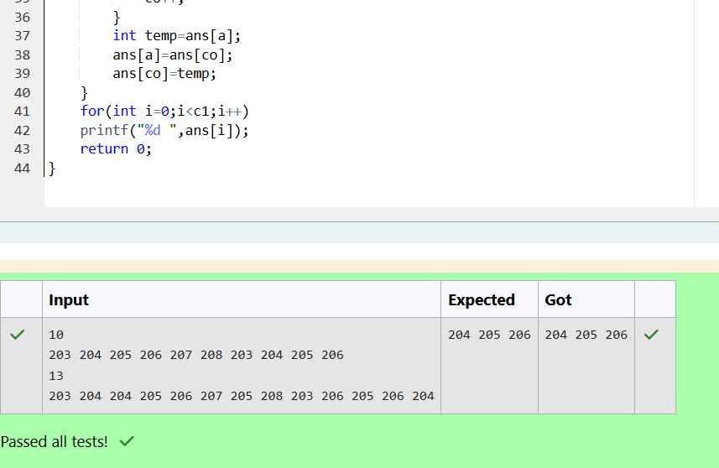
3.
Problem Statement:
Watson gives Sherlock an array of integers. Sherlock’s challenge is to find an element of the array such that the sum of all elements to its left is equal to the sum of all elements to its right.
Input Format:
- The first line contains TTT — the number of test cases.
- For each test case:
  - First line contains nnn, the size of the array.
  - Second line contains nnn space-separated integers representing the array.
Output Format:
For each test case, print YES if such an element exists; otherwise, print NO.
Sample Input:
Copy code
2
3
1 2 3
4
1 2 3 3
Sample Output:
objectivec
Copy code
NO
YES
